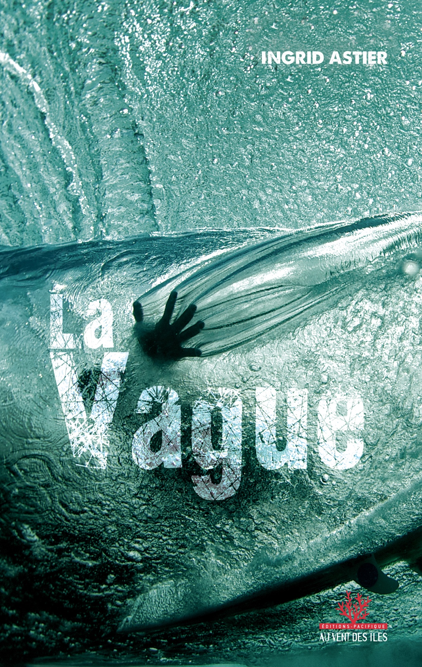 |   A LITERARY TRANSLATION SLAM  Catherine de Saint Phalle  vs  Frances Egan  moderated by  Mireille Vignol  Wednesday November 15, 6pm–7.30pm at RMIT  445 Swanston Street, Melbourne
AALITRA Literary Translation Slam 2023 (Moderator Mireille Vignol)

The Wave  Translation: Frances Egan  The first thing Lascar noticed as the guy got onto his boat without a word was the matching rash guard and shorts. Stars and Stripes. Well, that was a first. On the phone, the man had simply said that he wanted to surf Teahupo’o, had vaguely inquired about the weather conditions, and asked about the cost. Lascar had hesitated. The voice was authoritative, arrogant: a perfect fit for the person now standing in front of him. An arsehole. The whole thing would be over with barely a glance and a couple of crumpled notes. Unless Teahupo’o decided otherwise. Honestly, the wave could detect humility. Teahupo’o never lied.  Lascar throttled up and left the marina. In the sun, the palm trees took on a silvery sheen. At the bow, the man was finishing his cigarette. His bleached cowlicks hung over the board he was waxing. The wave was coming closer and he threw his butt into the water. Above, indifferent to the fate being decided, the clouds clung to the mountains. There was an offshore wind. The bastard was lucky as well as insufferable. What was his name again? Lascar jogged his memory as the foam pounded the sides of the boat. Taj? Yes, it must have been Taj.  Well, bienvenue, Taj! Welcome to hell. This is Teahupo’o, the wall of skulls.  The man took off his hooded jacket and applied sunscreen like warpaint. He got into the water. Lascar was convinced the party would not last long.  Beneath the clear water, the flag’s fifty stars rippled.  Taj, you forgot one, Lascar muttered. The best one. You forgot your lucky star.  He smiled to himself as the man, stretched out on his board, paddled smoothly towards the line-up.  Hiro was already there. He must have been the first.  Hiro was always first.  Lascar held his fist out towards him. Dawn was breaking. Small pink clouds were dancing all around. On the dormant volcanoes, ferns cascaded tirelessly down the slopes, producing a surreal shade of green that seemed to trap the light and soothe the eyes. Lascar greeted the mountains, as he did every time. Then he scanned Passe Have’a, but his dolphin friends had decided not to come.  It was because of his guest, he was sure. You had to win the dolphins over. It was as if they could sense connards like Taj.  In the fifteen years he’d been taking people to the Teahupo’o wave, Lascar thought he’d seen it all, from surfers to onlookers. But not that overinflated ego in the water. Who was this guy? Actually, he reminded him of someone. At the jetty, he’d seemed worked up. The kind of guy who had to be adjusted before he could socialise. What was he looking for here? Andy Warhol’s renowned fifteen minutes of fame? YouTube had brought that down to one. One minute of showing-off, but on a world scale. Also, Taj… It was a strange name. Was he from California, Florida? From the look of him, more likely Hawaii. Yes, he would have bet on Hawaii. Another guy from Kauai who thought he was Andy Irons.  He didn’t really care, after all. The wave would soon tell him who he was.  The board’s yellow tip sliced through the blue, resembling the sharp beak of this predatory wave catcher. On the boat, Lascar put Chemical Brothers on and rolled a joint. The local paka would detach him from these foreigners who suddenly became conquerors as soon as they set foot here – on land or sea. Conquering had never been his nature. Even with women, he let them come to him. Luckily, he was a surfer and not a fisherman, because he wasn’t good at reeling in a line. He preferred to tease the fish.  And the women.  Except with spearfishing.  He set his eyes on the horizon as he savoured his first drag. A wave formed. Lascar knew Hiro would let the foreigner take it.  The second would have time to turn to glass, like a jewel with a thousand reflections. The phenomenon was simple. Once at the break, the amateurs devoured everything they could. Wave guzzlers. It was like a beer festival, where the goal was to line them and line them up and keep a tally. They were there to drink. As if each pint soothed the emptiness inside these guys who wanted nothing more than to be.  Hiro was a master, next to them. He could spend hours waiting for The Wave. The one that, in a matter of seconds, could give him eternity. A wave that could loom as large as an airport. A wave that could have killed him already, a hundred times over. When the time came, Hiro would slot into the wave and let it wrap him in a perfect tube. So, Hiro heard the breath of the giant, then he went inside.  That’s right, Hiro was the master, respected by everyone.  And he would never brand his chest with the Milky Way to face the man-eating wave.  Lascar remembered seeing a tattoo of the wave on his body. Terupe’s design, as close as possible to his heart, where others marked the name of their first love or their mother.  Lascar also carried the wave in his heart. It was his mistress, his one true love.  The boat began to waltz with the ocean. A few metres away, the wall of water was rising up. A mass so powerful you had to see it at least once to believe it. From Antarctica, nothing stopped it for eight thousand kilometres. Teahupo’o. The mirage at the end of the road. La Vague. The dream of every waterman who deserved the title. Getting close to it was like meeting the devil in a frothy gown.  It was so beautiful it could drive you mad. Lascar could have looked at the Wave until the end of the world without getting bored. He wasn’t sure he could say the same of every woman he had known. Nor they of him.  He took another drag and time seemed to expand. In the morning light, the wave trapped all the blue of creation. The sea breeze had not yet risen and the colours of the water were clear and stretched – like Venetian glass. Lascar cast a glance at the coastline and its clusters of palm trees, took his bearings and positioned his boat so as to not get dragged in. A momentary lapse of attention and he would go under too.  The Teahupo’o angel was gliding past. A miracle of nature. A goddess who either raised you to the skies or smashed you to the ground. It was her choice.  The surfer beat his arms like a bird and made as if to take off. Lascar smiled. He knew what came next. The guy was about to swiftly double back before getting slashed to pieces by the reef. He recognised these kinds of bluffs. He guessed the wave was a good two metres high, which, at the break, was starting to get serious. Not quite a bomb yet, but serious. The first time you saw it, the overwhelming power of this wave took you by surprise. So did the reef just beneath the surface. Neither were forgiving. Surfers would come out with four-cheese pizzas on their backs. Lascar took a drag on his joint and added the smell of resin to the sea spray. He settled in to watch what happened next. Teahupo’o always put on a show.  Lascar looked toward the arena. Teahupo’o’s break was unusual. Instead of forming a straight line, it curved in a horseshoe, poised to capture its combatant. It was unique, insane. A true natural trap. Just as Lascar was about to take his bearings again on the coast, he saw the surfer stand up on the breaking wave. A steep take off that he hadn’t screwed up. Suddenly, Taj was a tiny, absolute point: man’s challenge to nature, on an almost ninety-degree slope. Lascar was speechless. Pride drew a white streak across the pristine blue, while the rest of the monster frothed with thick and creamy foam.  Lascar raised his glasses on his blue cap. He couldn’t believe it. The guy had ambition, technique, courage and style. The four combined qualities that were the only things that made an impression here.  Who the hell was he? He reminded him of…The joint was making his memory foggy.  Teahupo’o threw out its frothy lip. At its feet, the lagoon was emptying. Lascar saw the reef below, almost exposed. Everywhere, the coral threatened. Even the tanned leather of this warrior could not have withstood those sharp spikes. As the boat pitched, Lascar watched to see if Taj would emerge from the tube. Would he get ejected like a pinball or stay inside? It was Russian roulette. Maybe he would emerge peeled like an orange.  A hellish gust of wind swept over the boat, which was pelted with spray.  On his lips, Lascar tasted the salt – this place’s host. The wave was the deity, and he communed with it each time.  Pursued by the torrent, Taj appeared in the eye of the storm, one arm extended for balance. Then, he was on the wave’s shoulder, on the edge of the abyss, flirting with the unfurling monster’s precipice. He kicked out to escape, and paddled quickly toward the boat. Saved.  A little further offshore, Hiro hadn’t moved.  He was watching for the bomb that would come.  He wanted to dedicate it to Moea.  She was coming back. | La vague  Original text : Ingrid Astier  Le type monta sur son bateau presque sans un mot et Lascar remarqua d’abord le top en lycra assorti au short. Stars and Stripes. On ne lui avait encore jamais fait le coup. Au téléphone, l’homme lui avait juste dit qu’il voulait surfer Teahupo’o, s’était vaguement inquiété des conditions météo et avait demandé le prix. Lascar avait hésité. La voix était autoritaire, arrogante, et il avait désormais sous les yeux exactement la personne qui allait avec. Un enfoiré. Tout se terminerait sans un regard et quelques billets froissés. Sauf si Teahupo’o en décidait autrement. Pour dire le vrai, la vague avait un détecteur d’humilité.  Un détecteur qui ne mentait jamais.  Lascar mit les gaz et quitta la marina. Sous le soleil, les palmiers prirent des reflets argentés. À l’avant du bateau, l’homme finissait de fumer. Ses épis décolorés surplombaient sa planche qu’il waxait. La vague approchait et il jeta son mégot dans l’eau. Au-dessus des montagnes, les nuages restaient accrochés, indifférents au sort qui se jouait. Le vent était offshore. En plus d’être imbuvable, ce salopard avait de la chance. Comment s’appelait-il déjà ? Lascar secoua sa mémoire tandis que l’écume battait les flancs du bateau. Taj? Oui, ce devait être Taj.  Eh bien, welcome, Taj ! Bienvenue en enfer. Ici, c’est Teahupo’o, le mur de crânes.  L’homme retira sa veste à capuche et se fit des peintures de guerre avec la crème solaire. Puis il se mit à l’eau et Lascar eut la conviction que la fête foraine n’allait pas durer longtemps.  Dans l’onde transparente tremblaient désormais les cinquante étoiles du drapeau.  Taj, tu en as oublié une, marmonna Lascar. La meilleure. Tu as oublié ta bonne étoile.  Et il se sourit à lui-même, tandis que l’homme, allongé sur sa planche, ramait souplement vers le line-up.  Hiro était déjà là. Il avait dû arriver le premier.  Hiro arrivait toujours le premier.  Lascar tendit le poing dans sa direction. L’aube se levait. Partout, des petits nuages roses dansaient. Les fougères dévalaient inlassablement les pentes des anciens volcans et donnaient cette couleur d’un vert irréel, un vert qui aurait piégé la lumière tant il caressait le regard. À chaque fois, Lascar saluait les montagnes. Il scruta ensuite la passe de Hava’e mais ses amis les dauphins n’avaient pas daigné l’accompagner.  À cause de son hôte, il en était persuadé. Les dauphins se méritaient. À croire qu’ils avaient un sonar à connards.  Depuis quinze ans qu’il menait les hommes sur la vague de Teahupo’o, des surfeurs aux badauds, Lascar pensait avoir tout vu. Mais pas cet ego surdimensionné dans l’eau. Qui pouvait être ce type ? Il lui rappelait pourtant quelqu’un. Au ponton, il l’avait trouvé très excité. Le genre de mec qui a besoin d’un transformateur pour se sociabiliser. Que cherchait-il ici ? Le fameux quart d’heure de célébrité d’Andy Warhol ? YouTube l’avait réduit désormais à une minute. Une minute de frime. Mais à l’échelle de l’humanité. Et Taj, c’était un drôle de prénom. Venait-il de Californie, de Floride ? Vu la dégaine, plutôt d’Hawaii. Oui, il aurait parié sur Hawaii. Encore un mec de Kauai qui se prenait pour Andy Irons.  Après tout, il s’en fichait. La vague n’allait pas tarder à lui dire qui il était.  Fendant le bleu, la pointe jaune de la planche surnagea, bec acéré du rapace braqueur de vagues qu’elle portait. Lascar lança Chemical Brothers sur son bateau et se roula un joint. Le paka local le détendrait de ces étrangers qui se muaient en conquérants dès qu’ils posaient un pied, que ce fût sur terre ou en mer. Conquérir n’avait jamais été sa nature. Même les femmes, il les laissait venir. Heureusement qu’il était surfeur et non pêcheur car remonter une ligne n’était pas son fort. Les poissons, il préférait les taquiner.  Comme les femmes.  Sauf en chasse sous-marine.  Ses yeux se posèrent sur l’horizon tandis qu’il appréciait la première bouffée. Une vague se forma et Lascar sut que Hiro la laisserait à l’étranger.  La deuxième aurait le temps, comme un joyau, de se polir de mille reflets. Le phénomène était simple. Une fois au pic, les novices se précipitaient sur tout ce qu’ils voyaient. Des gobeurs de vagues. Un côté fête de la bière, où il s’agissait d’en aligner et d’en aligner pour les compter. Ils venaient pour consommer. Comme si chaque pinte rassurait ce vide en l’homme qui ne demande qu’à exister.  - côté, Hiro était un Prince. Capable de passer des heures à attendre la Vague. Celle qui, en quelques secondes, lui procurerait l’éternité. Une vague qui savait être aussi grande qu’un hall d’aéroport. Une vague qui, déjà cent fois, aurait pu le tuer. Le moment venu, il se glissait en elle et elle l’enrubannait d’un tube parfait. Alors, Hiro entendait le souffle du géant, puis il rentrait.  Oui, Hiro était un Prince, que tout le monde respectait. Et jamais il ne se serait collé la Voie lactée sur le torse pour affronter la vague mangeuse d’hommes.  Sur son corps, Lascar se souvenait d’avoir vu la vague tatouée, stylisée par Terupe. Au plus près de son cœur, là où d’autres portent le prénom de leur premier amour ou de leur mère.  Lascar aussi portait la vague dans son cœur. C’était sa maîtresse. La vraie.  Le bateau amorça une valse avec l’océan. À quelques mètres, le mur d’eau s’élevait. Une masse tellement puissante qu’il fallait la voir une fois dans sa vie pour le croire. Depuis l’Antarctique, rien ne l’arrêtait sur huit mille kilomètres. Teahupo’o. Le mirage du bout de la route. La Vague. Le rêve de tout waterman digne de ce nom. L’approcher, c’était croiser le diable en robe d’écume.  Elle était belle à se damner. Lascar aurait su la regarder jusqu’à la fin du monde sans se lasser. Il n’était pas sûr de dire la même chose de toutes les femmes qu’il avait connues. Et elles de lui.  Il tira une autre bouffée et le temps parut se dilater. Dans la lumière du matin, la vague piégeait tous les bleus de la création. Le vent de mer ne s’était pas encore levé et les teintes de l’eau étaient transparentes et étirées — du verre de Murano. Lascar lança un regard à la côte et ses nuées de palmiers, prit ses repères et plaça son bateau de manière à ne pas se faire entraîner. Un instant d’inattention et lui aussi sombrerait.  L’ange Teahupo’o passait.  Un miracle de la nature. Une déesse qui portait aux nues ou qui broyait.  C’est elle qui décidait.  Le surfeur battit des bras comme un oiseau et fit mine de se lancer. Lascar sourit. La suite, il la connaissait. Le type allait rebrousser chemin dare-dare avant de finir lacéré par le récif. Les coups de bluff de ce genre, il connaissait. Il évalua la hauteur de la vague à un bon deux mètres.  Ce qui, sur le spot, commençait à devenir sérieux. Pas encore une grosse bombe, non, mais du sérieux. La première fois, la surpuissance de cette vague surprenait, le récif à fleur d’eau aussi. Les deux ne pardonnaient pas. Les surfeurs gagnaient alors avec des pizzas quatre fromages dans le dos. Lascar tira sur son joint et mêla aux embruns des odeurs résinées. Il se cala pour attendre la suite. Avec Teahupo’o, on était toujours au spectacle.  Lascar contempla l’arène. Fait singulier, Teahupo’o ne déroulait pas de façon linéaire. Elle s’incurvait en fer à cheval, prête à piéger son guerrier. C’était unique, insensé. Un vrai piège-né. Au moment où Lascar s’apprêtait à vérifier de nouveau ses repères sur la côte, il vit le surfeur se dresser sur la vague qui déferlait. Un take-off rapide qu’il n’avait pas raté. Soudain, Taj fut ce point infime et absolu, ce défi de l’homme à la nature sur une pente à presque quatre-vingt-dix degrés. Lascar en resta bouche bée. L’orgueil traça un sillon blanc dans le bleu virginal tandis que le monstre s’ourlait, épais à souhait, crémeux d’écume. Lascar releva ses lunettes sur sa casquette bleue. Il n’en revenait pas. Le mec avait de l’ambition, de la technique, du courage et du style. Les quatre données réunies qui seules impressionnaient ici.  Bordel, qui il était ? Il lui rappelait… Le joint mettait de la brume dans sa mémoire.  Teahupo’o jeta sa lèvre frangée d’écume en avant et, à ses pieds, le lagon se vidait. En dessous, Lascar vit le récif, presque mis à nu. Partout, le danger du corail menaçait. Des pointes acérées : même le cuir tanné de ce guerrier n’aurait pu résister. Tandis que le bateau tanguait, Lascar guetta si Taj sortait du tube. Allait-il se faire éjecter comme une boule de flipper ou y rester ? C’était la roulette russe. Il ressortirait peut-être pelé comme une orange.  Un souffle infernal gagna le bateau qui fut criblé d’embruns.  Sur ses lèvres, Lascar sentit leur goût salé — l’hostie d’ici. À chaque fois, il communiait avec cette vague qui était leur divinité.  Talonné par l’avalanche, le corps de Taj apparut dans l’œil du cyclone, un bras tendu pour s’équilibrer. Puis il se retrouva sur l’épaule de la vague, à flanc d’abîme, flirtant avec l’arête vive du monstre qui déferlait, prit un virage pour s’échapper, et moulina rapidement vers le bateau. Sauvé.  Un peu plus au large, Hiro, lui, n’avait pas bougé.  Il guettait la bombe qui finirait par arriver.  Il voulait la dédier à Moea.  Moea qui revenait. | The Wave  Translation: Catherine de St Phalle  The guy set foot on his boat, with barely a nod, barely a word. With his Lycra top matching his shorts, you couldn’t miss him. Stars and Stripes – a first. On the phone, the man had just said that he wanted to surf Teahupo’o. He’d been vaguely concerned about the forecast and had asked about prices. Lascar had hesitated. The voice had been bossy and arrogant – this bastard in front of him suited it perfectly. It would all wind up with a few crumbled banknotes and no eye-contact. Unless Teahupo’o decided otherwise. It had to be said, the wave had a humility sonar.  And its sonar never lied.  Lascar stepped on the gas and left the marina. The palm trees stood in a silvery haze of sun. At the bow, the guy was finishing his cigarette. His bleached tufts hung over his board as he waxed it. The wave was coming close, and he threw his cigarette butt in the water. Up there, the clouds were hooked to the mountain tops, quite indifferent to the fate below them. As well as being unbearable, this pain in the neck was lucky – the wind was offshore. What was his name again? Lascar jiggled his memory as foam surged against the hull. Taj? Yes, that was it. Taj.  Well, welcome, Taj! Welcome to hell. This is Teahupo’o, the wall of skulls.  The man took off his hoodie and smeared on his warpaint of suntan-lotion. Then he got into the water. Lascar was suddenly convinced that the show wouldn’t be a long one.  The flag’s fifty stars now shivered in the sea.  Taj, you forgot one, mumbled Lascar. The best one. You forgot your lucky star.  He smiled to himself, while the man, lying prone on his board, paddled smoothly towards the line-up.  Hiro was already there. He must have arrived first.  Hiro always arrived first.  Lascar extended a fist in his direction. Dawn was breaking. Small pink clouds were popping about and dancing everywhere. Tirelessly, ferns slid down the old volcano slopes and infused the air with a dazzling green that caught the light and imprisoned the eye in its other worldly softness. As he did each time, Lascar greeted the mountains. He then scrutinised Hava’e’s pass, but this time his friends the dolphins hadn’t bothered coming along with him.  It was because of his guest. He was convinced of that. Dolphins could only be deserved. Surely, they had their own bullshit-detector.  He had been bringing men to the Teahupo’o wave for fifteen years. From surfers to sightseers, Lascar felt he had seen everything – but never had he seen such an oversized ego in the water. Who could this guy be? Yet he reminded him of someone. He had noticed how excited he was on the pontoon. The kind of guy who needed a transformer to socialise. What was he looking for? Andy Warhol’s famous fifteen minutes of fame? YouTube had now reduced it to a minute. A minute of hoo-ha – but on the scale of humanity. As for Taj, that was a weird first name. Did he come from California? Florida? From his look, one would rather suppose Hawaii. Another guy from Kauai who took himself for Andy Irons.  Anyway, he didn’t give a rat’s arse. The Wave wouldn’t take long to tell him who he really was.  Cleaving the blue water, the board’s yellow tip became the rapacious beak of the wave-predator it carried. Lascar turned on Chemical Brothers and rolled up a joint. The local paka would take his mind off these foreigners who turned themselves into conquerors as soon as they set foot on earth or sea. Conquering had never been in his nature. Even women – he let them come to him. Luckily, he was a surfer and not a fisherman. Reeling in the line was not his forte. Teasing fishes was what he preferred.  Like women.  Except for spearfishing.  Enjoying his first puff, he checked the horizon. A swell formed and Lascar knew that Hiro would leave it to the stranger.  The second one would have more time to gather a thousand reflections and polish itself into a blue jewel. It was a simple phenomenon. Once they had reached the peak, novices would throw themselves on anything that moved. Wave eaters. Beer festival devotees, aligning pints to make a tally, they came as consumers as if each pint soothed a void in man that begs for existence.  And there was Hiro. A prince… Ready to spend hours waiting for the Wave. The one which would grant him eternity in a few seconds. The one who knew how to be taller than an airport lounge. A wave which could already have killed him a thousand times. At the right moment, he’d slide into her, and she’d wrap herself around him in a perfect cone. Hiro would hear the giant’s breath, and he’d be in it.  Yes, Hiro was a prince, that everyone respected. Hiro would never stick the Milky Way on his chest to face the man-eating Wave.  On his body, Lascar remembered seeing the Wave tattooed and stylised by Terupe. Nearest to his heart, where others wore their first love’s, or their mother’s name.  Lascar also carried the Wave in his heart. She was his true mistress.  The boat started its waltz with the ocean. A few metres away, the water-wall was rising. You had to see it once in your life to believe its unbelievable power. From Antarctica, for eight thousand miles, nothing impeded its course. Teahupo’o. The mirage at the end of the road. The Wave. The dream of every self-respecting waterman. Approaching her, was to meet the devil in a dress of froth and foam.  A She-devil to die for and be damned. Lascar could have gazed at her till the end of Time without a blink. He wasn’t sure he’d be able to say the same thing about all the women he’d known. Nor they about him.  He took another puff and time seemed to expand. In the morning light, the Wave trapped every shade of blue in the world. The sea wind hadn’t lifted yet and the water hues had a translucent and stretched out quality – like Murano glass. Casting a glance on the coast and its swarm of palm trees, Lascar got his bearings, and positioned his boat to avoid being swept away. A moment of inattention, and he also would sink.  Angel Teahupo’o was passing.  A miracle of nature. A goddess that raised you to the skies or smashed you to smithereens.  She was the one to decide.  The surfer flapped his arms like a bird and pretended to take off. Lascar smiled. He knew how it ended. The guy would back down fast before being slashed by the reefs. He knew everything about these kinds of stunts. He assessed the Wave’s height to a solid two metres. Which, in this spot, was starting to be significant. Not yet a large explosive, but serious business. When encountered for the first time, the overwhelming power of the Wave was surprising. Flirting with the surface, the reef had its own power which could be just as fatal. The surfers would then win four-cheese pizzas on their backs. Mixing the sea spray with its resinous aroma, Lascar inhaled his joint. He settled back to await the rest of the proceedings. With Teahupo’o, it was always a show.  Lascar surveyed the arena. The odd fact was that Teahupo’o wasn’t unfurling in a linear fashion. She was curling herself into a horseshoe, ready to capture her warrior. It was quite unique, it was unbelievable. The ultimate trap. Just when Lascar was getting ready to check his landmarks on the coast again, he saw the surfer rise to the heaving wave. A swift take-off which he hadn’t missed. Suddenly, Taj was that infinitesimal and absolute dot, a man’s challenge to nature on a nearly ninety-degree slope. Lascar was gobsmacked. Pride traced a white furrow in the vestal blue as the monster hemmed itself thick with creamy froth. Lascar pushed up his glasses over his blue cap. He couldn’t believe it. The guy had ambition, technique, courage, and style. The four skills that were considered impressive here.  Fuck, who was he? He reminded him of … The joint was clouding his memory.  Teahupo’o threw her foamed, fringed lip forward. At her feet, the lagoon was emptying itself. Below, Lascar saw the reef exposed, nearly naked. The danger of coral was lurking everywhere. Vicious spikes and spurs: even this warrior’s tanned leather wouldn’t have withstood such an onslaught. As the boat pitched about, Lascar checked if Taj was coming out of the barrel. Would he be ejected like a pinball, or stay inside – and be lost? It was a Russian roulette. Perhaps he’d come out skinned alive.  An infernal gust reached the boat and riddled it with sea sprays.  Lascar felt their salty taste on his lips, which was the sacred host around here, every time a communion with their Godhead – the Wave.  Hounded by the avalanche, Taj’s body appeared in eye of the tornado, one arm extended to keep his balance. Then Lascar saw him on the wave’s shoulder at the very edge of the abyss, toying with its unfurling crest, before taking a sharp turn to make his getaway. And then, he was paddling swiftly towards the boat. Saved.  Hiro, a little further out, hadn’t budged.  He was awaiting the arrival of the bomb, which would finally turn up.  He wanted to dedicate it to Moea.  To Moea, who was coming back.

OF FLESH AND BONES, A COLLECTIVE PROMOTING HUMAN TRANSLATION, REQUESTS:
that publishers, providers of subtitling, dubbing and voice-overs, audiovisual production and distribution companies, video game studios, and media outlets refuse to resort to AI as a supposed tool for translation and for the creation of works of art and texts

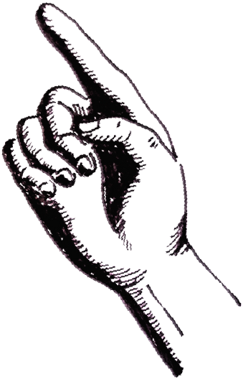
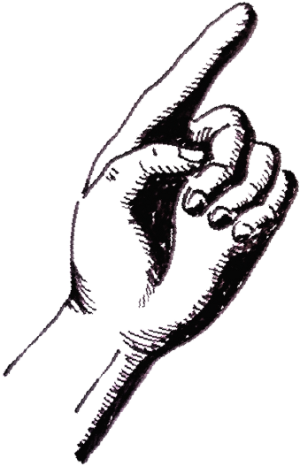
that publishers and broadcasters be obliged to indicate to the consumer any cultural product in which an AI has interfered, anywhere along the production line

that no public funding or support be granted to works entirely or partially created by AI

and calls upon all creators of works of the mind as well as all publishers and broadcasters to actively refuse all use of AI in the cultural domain

and upon the general public, who reads books, watches movies, plays
video games, and appreciates the works we create, to respond to our call and support our action, to be able to continue to enjoy a truly human culture, produced by human beings making an honourable living from their respective professions

FOR MORE INFORMATION VISIT https://enchairetenos.org

